**Bipartite Graph-**

A bipartite graph is a special kind of graph with the following properties-

* It consists of two sets of vertices X and Y.
* The vertices of set X join only with the vertices of set Y.
* The vertices within the same set do not join.

**Bipartite Graph Example-**

The following graph is an example of a bipartite graph-

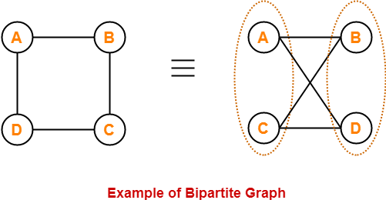

Here,

* The vertices of the graph can be decomposed into two sets.
* The two sets are X = {A, C} and Y = {B, D}.
* The vertices of set X join only with the vertices of set Y and vice-versa.
* The vertices within the same set do not join.
* Therefore, it is a bipartite graph.

## ****Complete Bipartite Graph-****

A complete bipartite graph may be defined as follows-

|  |
| --- |
| A bipartite graph where every vertex of set X is joined to every vertex of set Y  is called as complete bipartite graph.  **OR**  Complete bipartite graph is a bipartite graph which is complete.  **OR**  Complete bipartite graph is a graph which is bipartite as well as complete. |

### ****Complete Bipartite Graph Example-****

The following graph is an example of a complete bipartite graph-

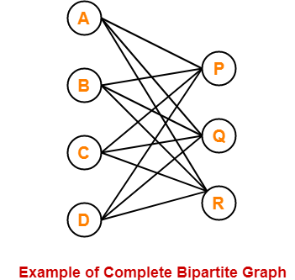

Here,

* This graph is a bipartite graph as well as a complete graph.
* Therefore, it is a complete bipartite graph.
* This graph is called as **K4,3**.

**Bipartite Graph Properties-**

Few important properties of bipartite graph are-

* Bipartite graphs are 2-colorable.
* Bipartite graphs contain no odd cycles.
* Every sub graph of a bipartite graph is itself bipartite.
* There does not exist a perfect matching for a bipartite graph with bipartition X and Y if |X| ≠ |Y|.
* In any bipartite graph with bipartition X and Y,

Sum of degree of vertices of set X = Sum of degree of vertices of set Y

## ****PRACTICE PROBLEMS BASED ON BIPARTITE GRAPH IN GRAPH THEORY-****

## ****Problem-01:****

Is the following graph a bipartite graph?

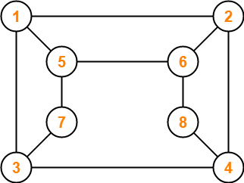

## ****Problem-02:****

The maximum number of edges in a bipartite graph on 12 vertices is _________?